
投標注意事項:
Bidding Documents Submission Notice:

- 請將所有投標文件備妥並密封於信封內。
Please make sure you have all bidding documents ready, and make sure your tender is in a sealed envelope.
- 請將外標封黏在快遞信封外如圖示。
Please paste our cover sheet on the outside of a forwarder’s envelope as below.
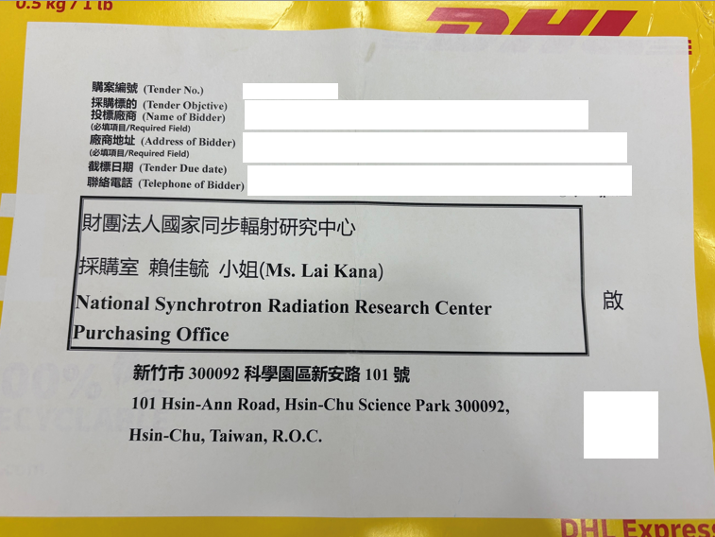
- 本案須檢附以下投標文件:
This required bidding document includes:
■設立登記證明
A Certificate of registration or establishment documents of under applicable law in your country
■用印之標價清單
A signed Submitted Proposal Price List with your Bid Price
■企劃書3份
Proposal in three complete sets, please elaborate on the following items in your proposal:

審 查 項 目 (Examination Item) | 項 目 說 明  (Description) | 配分(Score)
廠商信譽、履約能力及實績  (Tednerer’s reputation, performance capability and its achievement) | 1.廠商之人力、經營能力、聲譽及財務狀況(Tenderer’s man power, capability of business running, commercial credit and financial condition)  2.提供曾完成與本案類似之承做經驗與實績(Providing tenderer’s contract performance record or similar experience and achievement example)  3.廠商在全球或在台銷售業績與服務狀況(Tenderer’s sale outstanding accomplishment and its after-sales services description) | 15 分
技術規格性能  (Tenderer’s technical specifications, performance) | 1.產品設備內容（含軟、硬體架構或配置、主要配備內容及廠牌名稱）(Tenderer’s product description including its software, hardware structure, allocation, main equipment and manufacture brand)  2.有助於提升本案功能之額外配備等項目說明(How to upgrade its function and its necessary additional equiped item description) | 35 分
履約品質及管理執行能力(Tenderer’s performance quality and its management capability) | 1工作項目劃分品質內容與保證措施、交付項目與測試時程等規劃(Examinate tenderer’s mark off action items and its evaluat quality control description, delivery items and inspection planning)  ※請留意交期不得晚於契約規範之交期  ※Please note that a bidder should accept NSRRC required schedule, or offer an earlier delivery schedule. | 10 分
價格(Price) | 價格明細及分析(Price list and Cost breakdown) | 40 分

請於截標前將投標文件送達本中心。
Please submit your documents to NSRRC by closing deadline, 17:00 pm, November 14th, 2025 (Taipei Time).
※ 請留意投標文件逾期將不予受理。
Please note a late tender will not be considered.

Kind regards,

Kana Lai
Procurement Office
Tel:+886-3-5780281
E-mail address: lai.kana@nsrrc.org.tw

